

**Submission Date:**

**Submitted By:**

**1. Name:** MD. Yeasin Shazad Peal

**ID:** 232-15-102

**2. Name:** Supan Roy

**ID:** 232-15-716

**Section: 65 K**

**Department of CSE**

**Daffodil International University**

**Submitted To:**

**Teacher’s Name:** Mr. Tanim Ahmed

**Designation:** Lecturer

**Department of CSE**

**Daffodil International University**

**Topic:** DNA Profiling in Forensic Science: A Review

**Course Title:** Introduction to Biology and Chemistry for Computation

**Course Code:** CSE115

**ASSIGNMENT**

DNA Profiling in Forensic Science: A Review

It has always been the main objective of forensic scientists and criminal investigators to be able to identify the origin of biological evidence found at a crime scene with certainty. DNA profiling allows the investigation of human biological material at its elemental level – the DNA molecule, that is located in every living cell within the biological system, which contains the genetic material that distinguishes an individual from others.

**Introduction**

A common technique for verifying the accuracy of evidence used in forensic investigations is forensic identification. Integrative components of forensic identification that have probative significance are criminalities and medico-legal identification. A specialist's capacity to match traces left at the crime scene with traces found on other materials, such as reference evidence, is what gives an identification approach its value.

Through this process, it is possible to compare biological samples from the victim and the suspect with traces of blood, saliva, or any other biological material, discovered on a suspect's clothing. Scientific procedures or intrinsic scientific processes that have been adopted from other sciences, typically biomedical sciences, provide the basis of medico-legal identification. In the previous 30 to 40 years, scientific advancement has highlighted and is still highlighting the role of professionals in identification. Their importance has been shown in instances involving civil, family, and criminal law as well as in those involving tragedies with large numbers of victims (accidents, natural disasters, terrorist attacks, and wars). Sir Alec Jeffreys used this method in the field of forensic genetics along with Mullis, who discovered the polymerase chain reaction (PCR) in 1983. Sir Alec Jeffreys studied a set of DNA fragments that revealed to have unique properties that were nonrecurring and intrinsic for each individual, with the exception of identical twins. Alec Jeffreys named these reaction products “genetic fingerprints.”

PCR procedure is correct as per the reference.

**DNA Structure and Genome**

DNA is sometimes referred to as the "blue print of life," because it contains all of the information that an organism needs to function and reproduce. Watson and Crick presented the model of DNA's double-helix structure. The DNA molecule is a nucleotide polymer. A nitrogenous base, a five-carbon sugar (deoxyribose), and a phosphate group make up each nucleotide. In DNA, there are two purines (adenine and guanine) and two pyrimidines (cytosine and thymine). Each base attracts to its opposite base: adenine is always attracted to thymine, while cytosine is always attracted to guanine base.

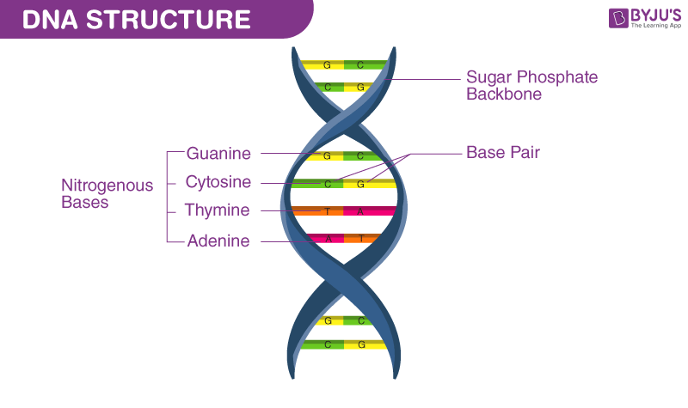

Fig. 1: Structure of DNA.

**Classification of HumanGenome**

Based on the structure and function, Classification of Human Genome into following different types.

1. **Coding and regulatory regions**: The regions of DNA that encode and regulate protein synthesis are called genes. A human genome comprises 20,000 to 25,000 genes; 1.5% of the genome is involved in protein coding.
2. **Noncoding:** Overall, 23.5% of the genome is classed as genetic sequence but is not involved in protein enclosing; instead, they are primarily involved in gene control, including enhancers, promoters, repressors, and polyadenylation signals.
3. **Extragenic DNA:** Approximately 75% of the genome is extragenic, and 45% of this is made up of interspersed repetitions and 50% repetitive DNA. Four common types of interspersed repetitive elements are: (i) short interspersed elements, (ii) long interspersed elements, (iii) long terminal repeats, and (iv) DNA transposons.

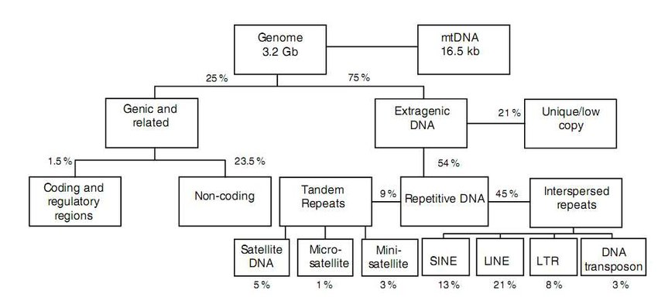

**Genome and Forensic Genetics**

Fig. 2: Classification of human genome.

DNA loci used in forensic genetics should have the following desired properties:

i) Should be extremely polymorphic.

ii) Characterization should be simple and inexpensive.

iii) They should be straightforward to comprehend and compare amongst laboratories.

iv) The mutation rate should be minimal.

**Sources of Biological Evidence**

Forensic genetic profiling requires biological samples having nucleated cells, such as: Liquid blood or dry deposits, Liquid saliva, semen, or dry deposits. Hard tissues like bone and teeth, Hair with follicles.

**Collection and Handling of Material at the Crime Scenes**

One of the most popular sources of DNA is whole blood. It is originally stored at 4°C for 5 to 7 days while being maintained in an anticoagulant (ethylenediamine tetraacetic acid). Following this time, DNA samples are stored at -20°C for a few weeks or longer at -80°C. With a sterile brush or bud, epithelial cells from crime scenes are extracted. Following harvest, they are wrapped in paper or plastic and maintained at room temperature in a dry atmosphere.

As improper treatment of the evidence might have major repercussions, it is crucial that the appropriate precautions are taken, such as maintaining the integrity of the crime scene and donning face masks and full protective suites during the investigation of the scene. In worst cases, cross-contamination leads to high level of sample degradation; this can confuse or avert the final result of evidence.

**Characterization of DNA Analysis:**

Basic Steps1 Analysis of DNA involves four basic steps, which are as follows:

1. DNA extraction.

2. DNA quantification.

3. DNA amplification.

4. Detection of the DNA-amplified products.

**DNA Extraction**

There are various methods of extraction as mentioned below, though commonly used are Chelex-100 method, silica-based DNA extraction, and phenol–chloroform method.

1. Chromatography-based DNA extraction method, 2. Ethidium bromide–cesium chloride (EtBr-CsCl) gradient centrifugation method, 3. Alkaline extraction method, 4. Silica matrices method, 5. Salting-out method, 6. Cetyltrimethylammonium bromide (CTAB) extraction method,

7. Phenol–chloroform method. 8. Sodium dodecyl sulfate (SDS)-proteinase K method, 9. Silica column-based DNA extraction method, 10. Magnetic beads method, 11. Cellulose-based paper method, 12. Chelex-100 extraction method, 13. Filter paper-based DNA extraction method.

**DNA Quantification**

After DNA extraction, it is desirable to measure the quantity and quality of the DNA extract accurately. The best quality is produced quickly when the right amount of DNA is supplied to the PCR process. A profile will be challenging or impossible to evaluate if less or more DNA is included.

|  |  |
| --- | --- |
| **Type of sample** | **Amount of DNA** |
| Liquid blood | 30,000 ng/mL |
| Stain of blood | 200 ng/cm2 |
| Liquid saliva | 5,000 ng/mL |
| Hair (with root) shed | 1–12 ng/root |
| Hair (with root) plucked | 1–750 ng/root |
| Liquid semen | 250,000 ng/mL |
| Postcoital vaginal swab | 0–3,000 ng/swab |
| Oral swab | 100–1,500 ng/swab |
| Urine | 1–20 ng/mL |
| Bone | 3–10 ng/mg |
| Tissue | 50–500 ng/mg |

**Table 1**: Various sources of biological evidence

**DNA Amplification**

Although there are eight DNA and RNA-based methods, PCR and reverse transcription-PCR have been the most widely used methods.

The method most frequently used for amplifying DNA is called PCR. With 30 cycles of amplification, even a single molecule can be expanded to a billion times its original size thanks to PCR. DNA amplification occurs in cycling phase, which consists of three stages.

1. Denaturation. 2. Annealing. 3. Extraction

After the amplification of DNA, the final step is detection of the DNA-amplified products.

**Detection of the DNA-Amplified Products**

The methods mentioned below are employed in forensic human identification:

1. Autosomal short-tandem repeat (STR) profiling

2. Analysis of the Y chromosome

3. Analysis of mt-DNA.

4. Autosomal single-nucleotide polymorphism (SNP) typing.

**Autosomal STR Profiling**

STRs are the gold standard in human identification in forensics. STR consists of mononucleotide, dinucleotide, trinucleotide, tetranucleotide, pentanucleotide, and hexanucleotide repeats of which tetranucleotide repeats are used for genotyping.

**Analysis of the Y Chromosome**

A male person biologically has 1 Y chromosome, which contains 55 genes. Because of this distinctive quality, Y chromosome analysis is carried out in criminal instances.

**Application of Y chromosome in forensic medicine:**

It is only found in males. Thus, in criminal investigations, investigators hope to find the Y chromosome at the crime scene. Also, when discussing the male-female ratio in body fluid mixtures, such as sexual assault or rapes, investigators can gain more information about the male component by evaluating the Y-STR component. It is commonly known that azoospermic or vasectomized rapists do not leave sperm traces, and spermatozoa cannot be found under a microscope. In such circumstances, Y-STR profiling is quite beneficial, providing information about the identity of the accused.

**Analysis of Mitochondrial DNA (mt-DNA)**

Since mt-DNA is passed down from mother to child, a matrilineal family's members all have the same haplotype.

**Autosomal Single-Nucleotide Polymorphism Typing**

Comparing SNP to STRs, the heterozygosity is lower for SNP. SNP typing has the advantage over STR typing in that the DNA template size can be up to 50 BPs, but STRs require a size of 300 BPs to achieve excellent STR profiling. SNP has consequently emerged as a crucial tool in the analysis of damaged materials. So, using SNP typing, victims of the 2001 World Trade Center disaster were identified.

**DNA Database – CODIS**

The establishment of DNA databases is another significant advancement in DNA profiling. The introduction of a national database in the United States allowed forensic scientists to enter unmatched DNA evidence found at the crime scene into a computerized system in order to make DNA matches. The Combined DNA Index System is known as CODIS. The Federal Bureau of Investigation (FBI) established and supported it in 1990, and it has since become the foundation of the US DNA database. It was created to enable it easier for open access forensic DNA testing institutions to create databases of authorized DNA profiles that can be searched.

United States laboratories can share and compare data thanks to the CODIS initiative. In addition, a central database containing all DNA profiles from all user laboratories is included. TH01, TPOX, CSF1PO, vWA, FGA, D3S1358, D5S818, D7S820, D13S317, D16S539, D8S1179, D18S51, and D21S11 are the 13 CODIS locations. The United States maintains the largest DNA database in the world: The Combined DNA Index System, with over 60 million records as of 2007.

**Recent Advancement**

The science of DNA profiling has undergone many changes during these intervening years and will continue to do so in future. Even though several typing methods have been established and were used to deduce the identity or genetic linkage of individuals, other genetic markers are being used to determine certain phenotypic traits to a good degree of accuracy. Genetic testing such as next-generation DNA sequencing, adapted from medical and pharmaceutical sciences, will soon be applied to mainstream forensic science, opening new avenues in criminal investigations. 53 The forensic community, faces the question of direction towards which the DNA fingerprint technology will be developed. With the help of commercial instruments being developed and introduced in the market, time, another essential factor in police investigations will be considerably reduced in future applications of DNA profiling. Presently employed DNA profiling with STR markers involves use of fluorescent dyes in order to label PCR products and capillary electrophoresis (CE) in order to rapidly separate and analyse the dye-labelled PCR products respectively. Future advances in forensic DNA analysis will probably mirror genomic technology. 55 As forensic DNA typing techniques advance, forensic scientists will analyse more form of evidence in order to find answers for questions otherwise deemed unresolvable with traditional DNA analyses (56). For instance, Vidaki and Kayer (2018) studied how epigenetics as well as markers for DNA methylation were proposed to estimate age, determine tissue type, and even differentiate between monozygotic twins.

**Discussion**

DNA profiling is one of the biggest achievements of the late 20th century. The first criminal case which used DNA analysis from biological evidence was in 1987, and since then, it has totally changed how forensic investigations are conducted. The sensitivity, speed, and power of DNA profiling techniques have significantly improved during the subsequent three decades. The fast-growing discipline of forensic genetics has produced a number of novel techniques that allow the analysis of challenging forensic evidence and reveal information about the source of the biological sample. With modern technology, the amount of DNA needed for analysis can now be extracted from even a minute biological sample, which enables relevant authorities to match suspects to evidence found at the crime scene.

**Conclusion**

DNA is the genetic code that is located in each and every cell of within an individual’s body. Although only 99.9 percent of DNA sequences is similar in every person, it is the 0.1 percent of the DNA difference that is unique to the individual and the forensic scientists are interested in. Typically, forensic DNA analysis is carried out in following steps: Sample preparation, DNA extraction, DNA amplification, DNA quantitation, and DNA profile matching where the profile obtained from crime-scene evidence is either entered into DNA database for comparison or compared directly with that from the suspect to determine whether suspect contributed DNA to the crime scene or not. Forensic DNA analysis has played an increasingly crucial role in criminal justice system.